EXP. NO: 1
Estimation of Characteristic Impedance (Zo), and Propagation Constant(γ) of a Transmission Line from Primary Constants.

Test Case 2:
Examine the impact of resistance and inductance on the significance of Characteristic
Impedance (Zo) and Propagation Constant (γ) of a Transmission Line at a frequency f=2.5
Khz. Vary the resistance value from 10 Ω to 50 Ω at the interval of 10 Ω with L,G and C
values constant and calculate the Characteristic Impedance and Propagation Constant .
Vary the inductance values from 3.5 mH to 11.5 mH at the interval of 2.5 mH with R,G and
C values constant.
AIM: To examine the impact of resistance and inductance on the significance of
Characteristic Impedance (Zo) and Propagation Constant (γ) of a Transmission Line at a
frequency f=2.5 Khz. Vary the resistance value from 10 Ω to 50 Ω at the interval of 10 Ω with
L,G and C values constant and calculate the Characteristic Impedance and Propagation Constant
. Vary the inductance values from 3.5 mH to 11.5 mH at the interval of 2.5 mH with R,G and C
values constant.
SOFTWARE REQUIRED:
SCILAB Version 6.1.1
PROCEDURE:
● Open SCILAB software
● Open file-new
● Put the input values
● Type the program
● Execute the program
● End the program
PROGRAM:
clear; clc;
R=10;L=0.003;f=2*10^3;G=4*(10^-6);C=16*(10^-6);
w=2*%pi*f;
Z=R+(%i*w*L);
Y=G+(%i*w*C);
Zo=sqrt(Z/Y);
C=round(real(Zo));
D=round(imag(Zo));
printf('-Zo = %f + j(%f)ohms\n',C,D);
P=sqrt(Z*Y);
a=real(P);
a1=round(a*10000)/10000;
printf('-Attenuation constant a = %f neper/km\n',a1);
b=imag(P);
b1=round(b*10000)/10000;
printf('-Phase constant b = %f radians/km',b1);
OUTPUT:
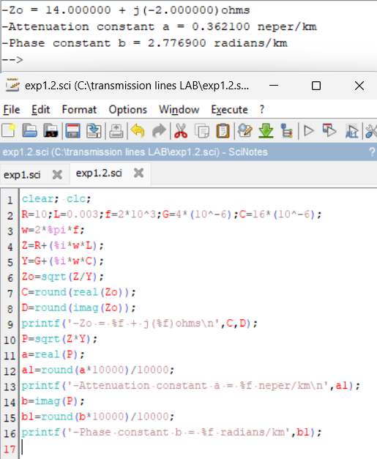

RESULT:
The impact of resistance and inductance on the significance of Characteristic Impedance (Zo)
and Propagation Constant (γ) of a Transmission Line is examined at a frequency f=2.5 Khz.

